To: Thai - Hong Kong Trade Association Fax: 02 343 9029 E-mail: thai-hongkong@thta.or.th
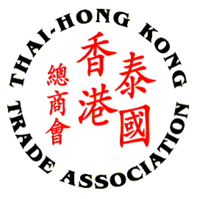

GET TOGETHER PARTY 2018
June 5, 2018 (Tuesday) from 6:00 -9:00 PM
At The Peninsula Bangkok
(BTS: Saphan Taksin Station, hotel shuttle boat every 15 minutes)

THTA Members – Free of Charge (2 representatives for Corporate Members,
1 for Affiliate member)
Non-THTA Members and Additional Guests –THB 1,000/person

No. | Name – Surname | Position
1
2
3
4
5

Name of Contact: __________________ Company : _____________________________
Tel : __________________________________ Fax : _____________________________ Email :__________________________________________________________________

Please make payment by transfer to Thai-Hong Kong Trade Association, Krungthai Bank, Queen Sirikit National Convention Center branch A/C no. 009-1-72633-6.

Remark: Please kindly confirm your participation by returning this registration form to THTA Office via E-mail: thai-hongkong@thta.or.th or Fax: 02 343 9029 by May 31, 2018.

